Cyberbullying Statistics

ComScore releases its Southeast Asia Digital 2013 Report. The region which has more than 62 million web users is spending their time on social networking sites. And it says that out of six countries in Southeast Asia that is home of 62 million online populations contributing more than 40% internet users from APAC, states the ComScore 2013 report Philippine is on the 4th Place.

**Sources:** [**http://lighthouseinsights.in/comscore-southeast-asia-digital-2013-report-62m-web-users-facebook-leads-followed-by-twitter-linkedin-and-tumblr.html/**](http://lighthouseinsights.in/comscore-southeast-asia-digital-2013-report-62m-web-users-facebook-leads-followed-by-twitter-linkedin-and-tumblr.html/)

**Ps: Year 2013 Statistics**

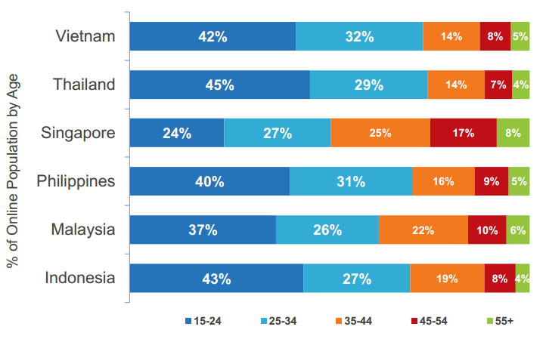

Figure1: Describes the percentage of the ages of the social Medias user.

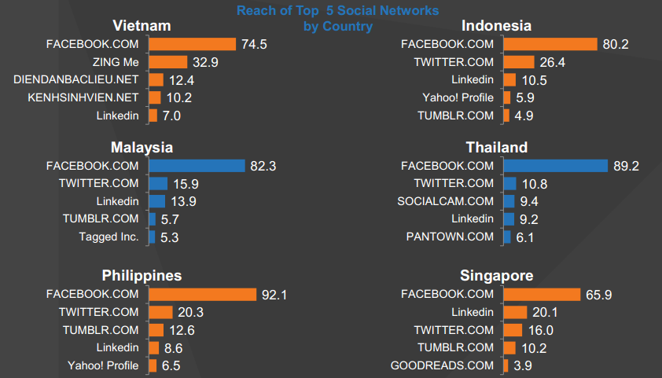

Figure2: This Describe the percentage of most visited social networking sites.

This data is based on The Statistics Portal that shows the internet penetration rate in selected Asia Pacific markets in as of July 2016. During the survey period, the estimated internet penetration in the Philippines was 43.5 percent.

Sources: <http://www.statista.com/statistics/281668/internet-penetration-in-southeast-asian-countries/>

**PS: Year 2016 Statistics**

Figure3: Out of 28 countries in Asia Pacific, Philippines is in 14th

This Data was conducted in Bullying in South-East Asian Countries: A review. This Data shows the percentage of cyberbullying in every year therefore, as the year pass by cyberbullying is also increasing.



Figure4: Bullying in South-East Asian Countries: A review – Percentage of pupils respond.

**Other Documents that have cyberbullying statistics**

Student Reports of Bullying and Cyber-Bullying: Results from the 2007 School Crime Supplement to the National Crime Victimization Survey

Determinants for Bullying Victimization among 11–16-Year-Olds in 15 Low- and Middle-Income Countries: A Multi-Level Study

Cyberbullying among Filipino Adolescents

PREVALENCE OF BULLYING IN RIZAL TECHNOLOGICAL UNIVERSITY: A BASIS FOR A PROPOSED INSTITUTIONAL GUIDELINES AND PROCEDURES